**Profesisonal Portfolio**

by

Leandro Machado

Student Number

300326045

Douglas College  
Faculty of Business

CSIS 1280

Anupama Gupta

04 November 2020

## PROJECT SUMMARY

## DESCRIPTION

As a developer, an online portfolio works like a business card. The project titled Professional Portfolio is an attempt to produce, at least, a first version of one. To achieve such an objective, the developer uses three technologies: HTML, CSS and JavaScript.

The HTML and CSS are the noun and adjectives of a website, whereas JavaScript is known as the verb. Along with JavaScript, the jQuery framework will be used to help the development of effects and animations.

The project structure is as shown in Figure 1:

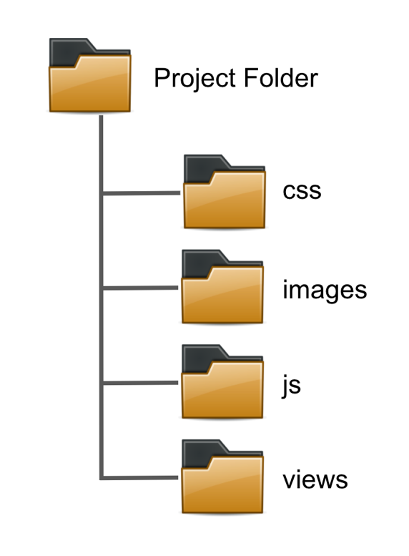

Figure -Project structure.

The root (project folder) will contain for folders: css, images, js and views. The css folder will have all files related to the styling of the page. The images folder will contain all photos and media related to the webpage content. The js folder will include the JavaScript files associated with the web page's behaviour, and the views folder will host all the .html files.

## WIREFRAME

The following set of wireframes represent the layout of the page.

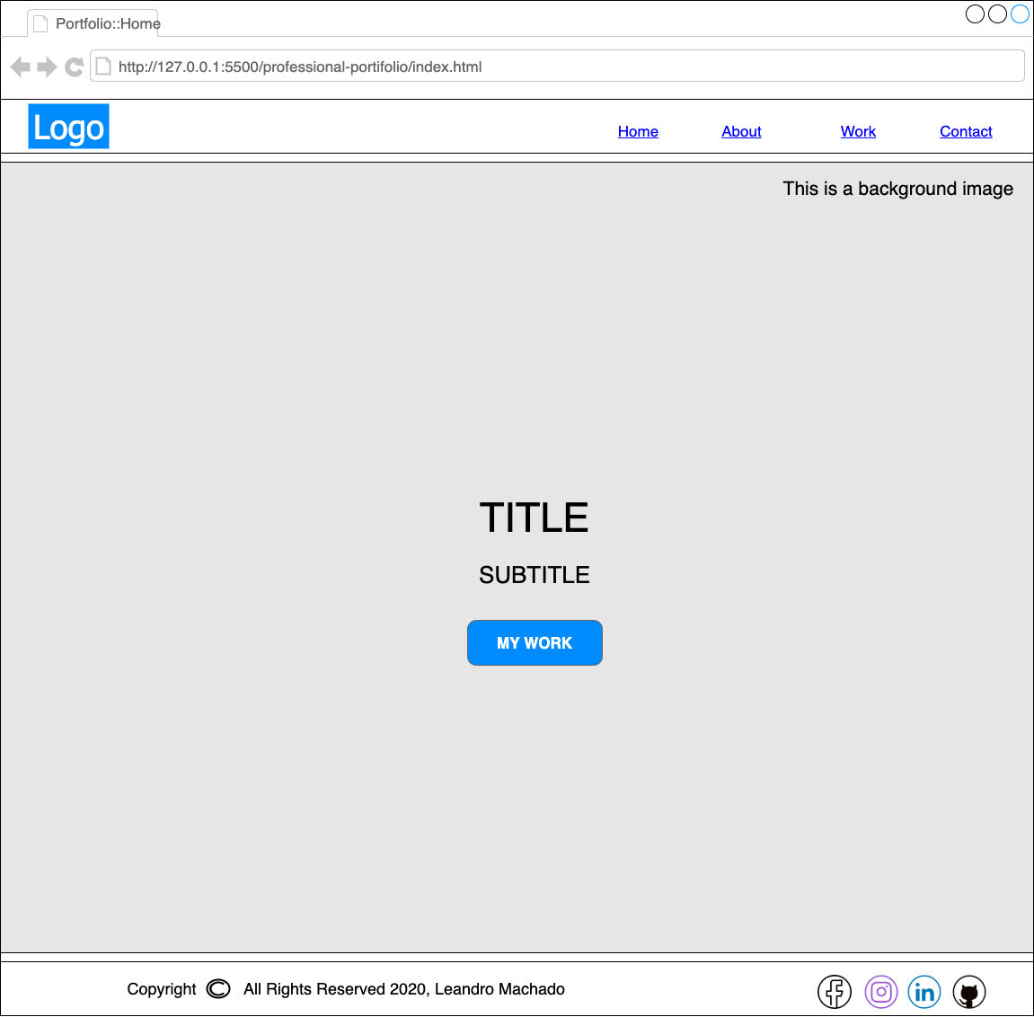

Figure - Home page.

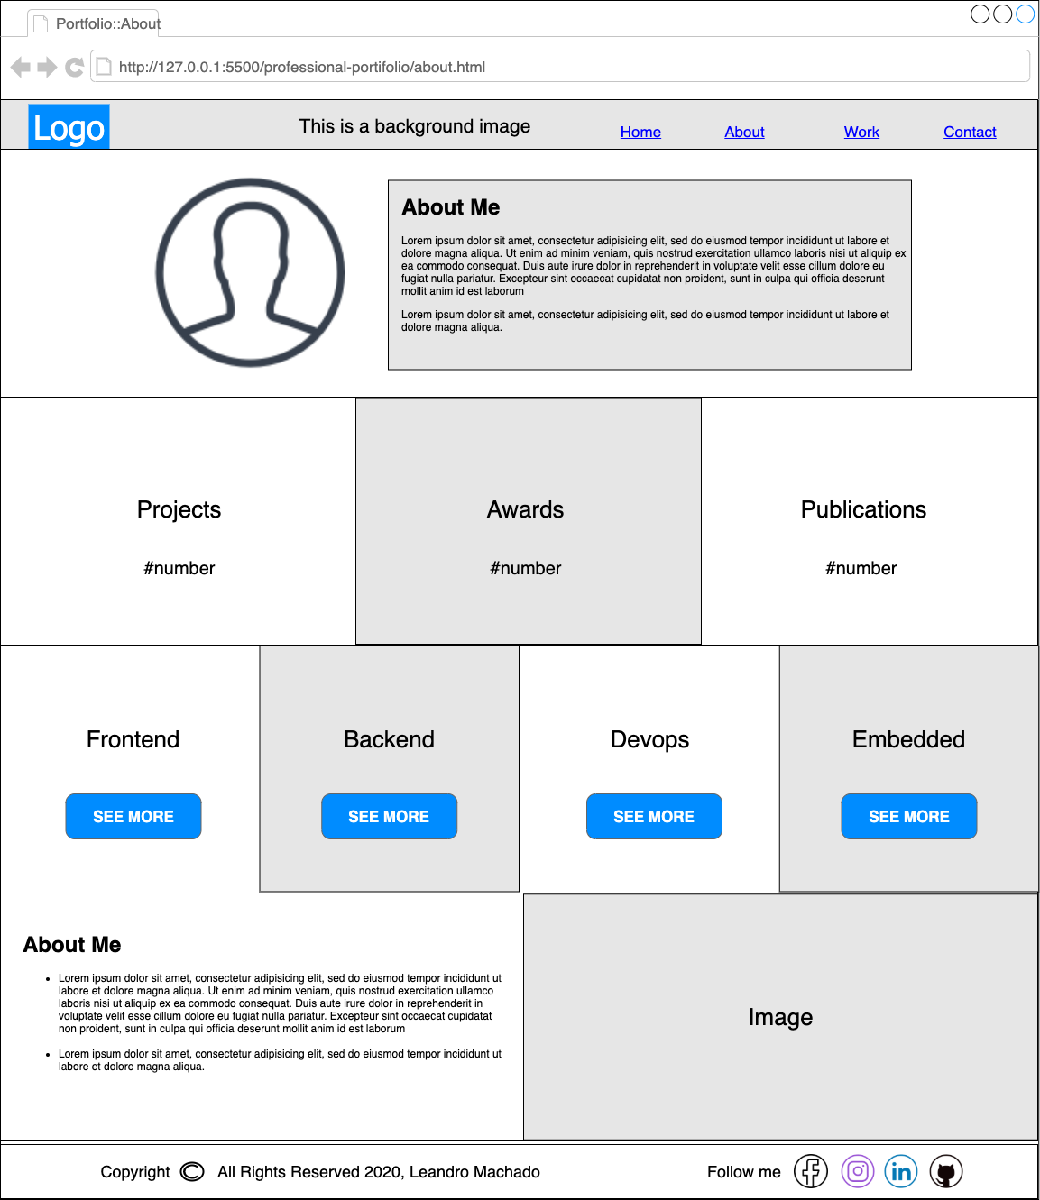

Figure - About page.

## 

Figure - Work page.

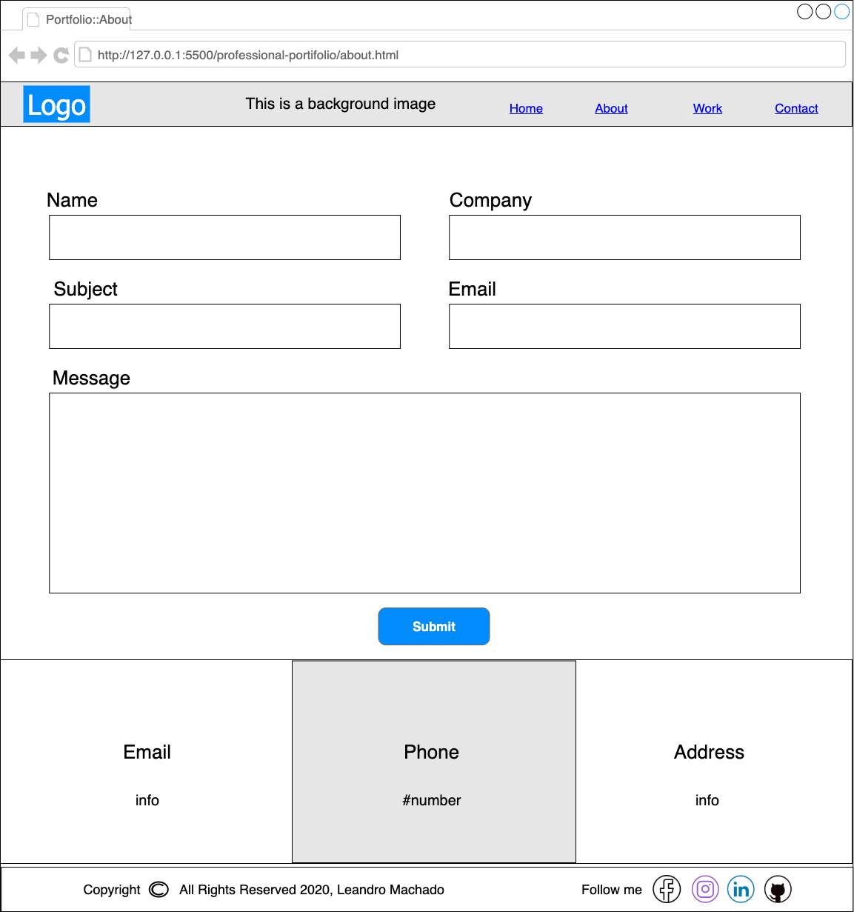

Figure - Contact page.

## SITEMAP

## STRUCTURE OF EACH WEBPAGE

## CONCLUSION

Reference List

Bobbitt Jr., H. R., & Ford, J. D. (1980). Decision-Maker Choice as a Determinant of Organizational Structure. Academy of Management Review, 5(1), 13–23. <https://doi.org/10.5465/AMR.1980.4288839>

Robbins, S. P., Coulter, M., Leach, E., & Kilfoil, M. (2018). Management: Twelfth Canadian Edition. Upper Saddle River, NJ: Pearson Canada.